Secure Tip-Off to Crime Authorities about Suspicious Crime Activities

Often peoples avoid being witness to crime as they fear their person details will be exposed and criminals will take some action against them and because of such fear many criminals will get full chance of committing crimes. To overcome from such issue we are providing secure platform for witness where they can give tips about suspicious to authorities without their details exposed to authorities or criminals.

To provide secure communication between users and server we are employing AES encryption algorithm

To secure user data from being tamper we are employing Blockchain Ethereum tool where data stored cannot be modify in any manner

For authorities to get accurate tips we are employing Tensorflow CNN (convolution neural network) algorithm to analyse tips and then predict it as True or false

While giving tips user can upload images and other files

We have employed DJANGO python web framework which has in built support for efficient data processing and load balancing

Each tip will be display to user or authorities as tabular format

Each tip will have ML prediction from CNN as True or False report

We have covered above points in our implementation and to secure user data we have employed Blockchain technology which will store each record as Block/transaction and associate each block with unique hash code and before storing new record Blockchain will verify hash code of all previous blocks and if data not alter then it will result into same hash code and verification will get successful otherwise get failed and due to this reason Blockchain will be consider as tamper proof.

Blockchain save or retrieve data with the help of Smart Contract which will be designed using Solidity code and this contract will contains function to save and get data from Blockchain. In below screen displaying Smart Contract code

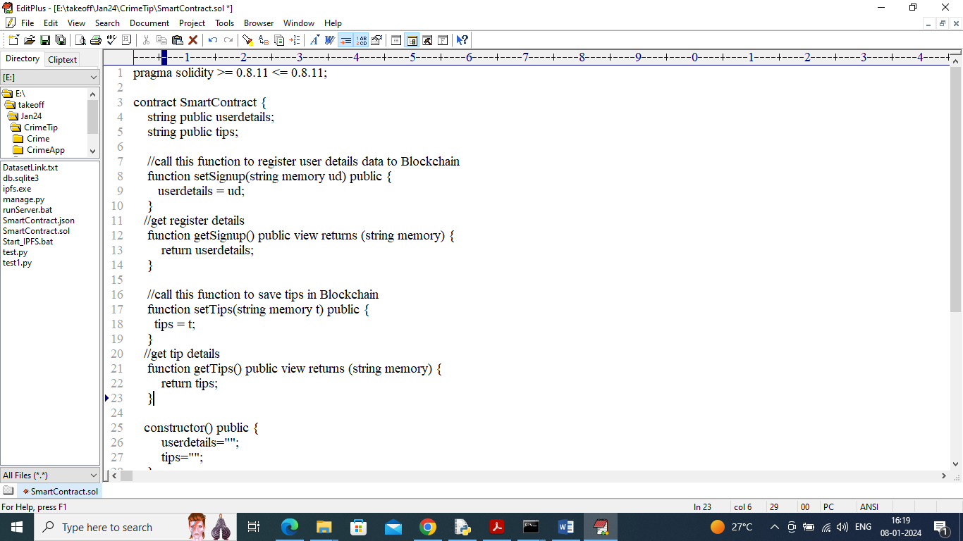

In above contract we have define function to save and get user and their TIP details and we need to deploy above contract in Ethereum tool using below steps

1. First go inside ‘hello-eth/node-modules/bin’ folder and then find and double click on ‘runBlockchain.bat’ file to start Ethereum tool and then will get below screen
2. 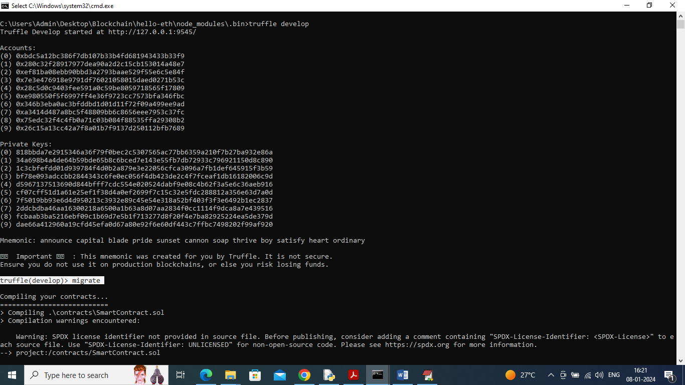
3. In above screen Ethereum tool started with default private keys and account and now type command as ‘migrate’ and press enter key to deploy contract and then will get below page
4. 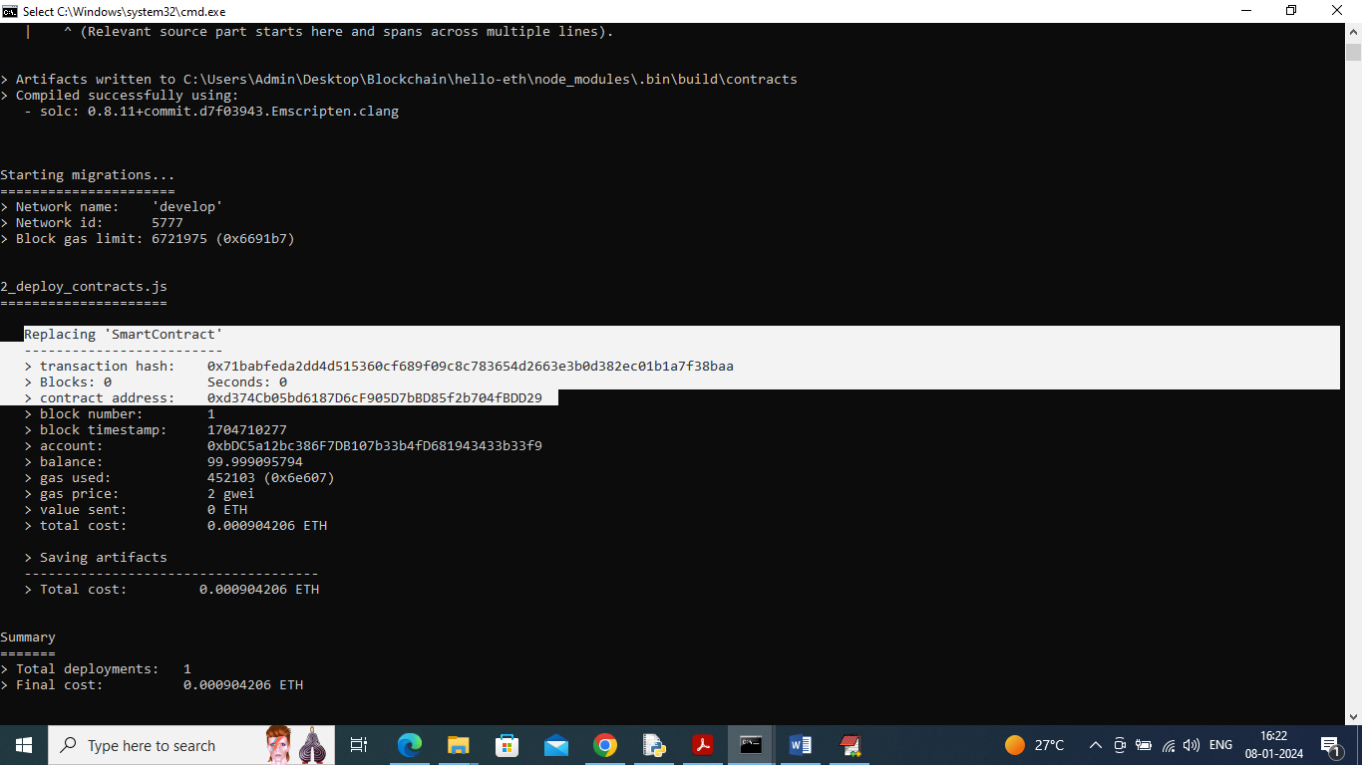
5. In above screen in white colour text can see ‘Smart Contract’ deployed and got contract address also and this address need to specify in python code to save and get details from Ethereum and in below screen showing python code calling smart contract using address
6. 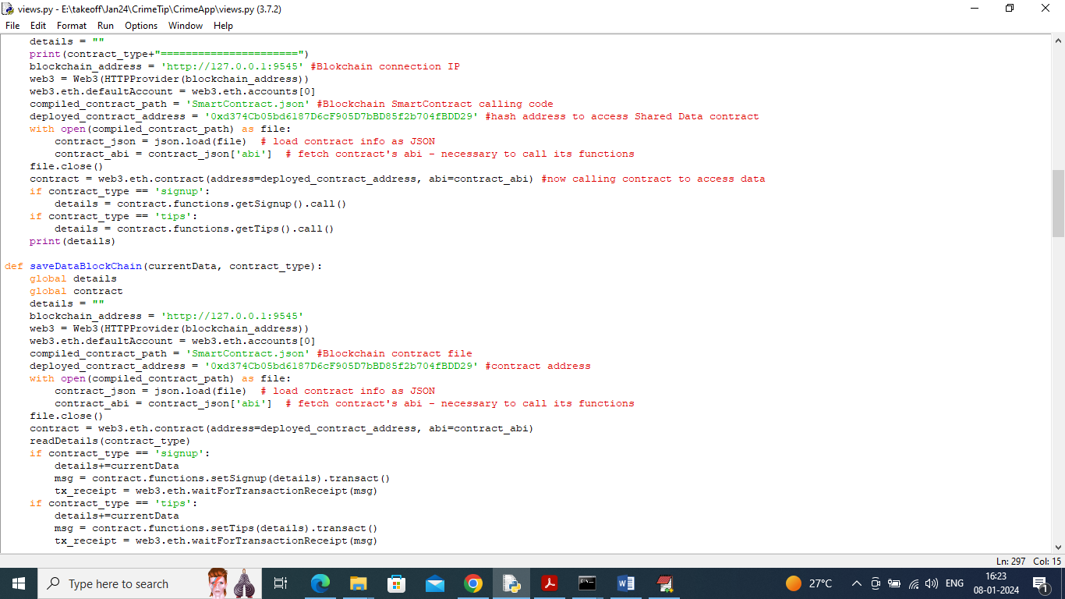
7. In above screen read red colour comments to know about contract calling using python and now contract is deployed and let it run.

To implement this project we have designed following modules

1. New User Sign up: using this module user can sign up with the application
2. User Login: using this module user can login to application and all user details will be managed with server in AES encrypted format
3. Submit your Tip: after login using this module user can submit tip about any suspicious activities
4. View your Past Tips: using this module user can view all submitted tip reports
5. Authority Login: authority can login to system using username and password as ‘admin’. After login authority can perform following options
6. Train ML: using this module authority can train ML to predict weather submitted tip is false or true
7. View Submitted Tips Report: using this module authority can view all submitted tips and machine learning predicted top status as true or false
8. View User Lists: using this module authority can view all registered user details but all username will be anonymised for security reason

To store multimedia data we are using IPFS (interplanetary file system) server which will store multimedia data and then returned stored location as hash code which will get saved in Blockchain and this hash code will be used to read back file from IPFS

To train ML algorithm we have used below TIP dataset which contains TIP description

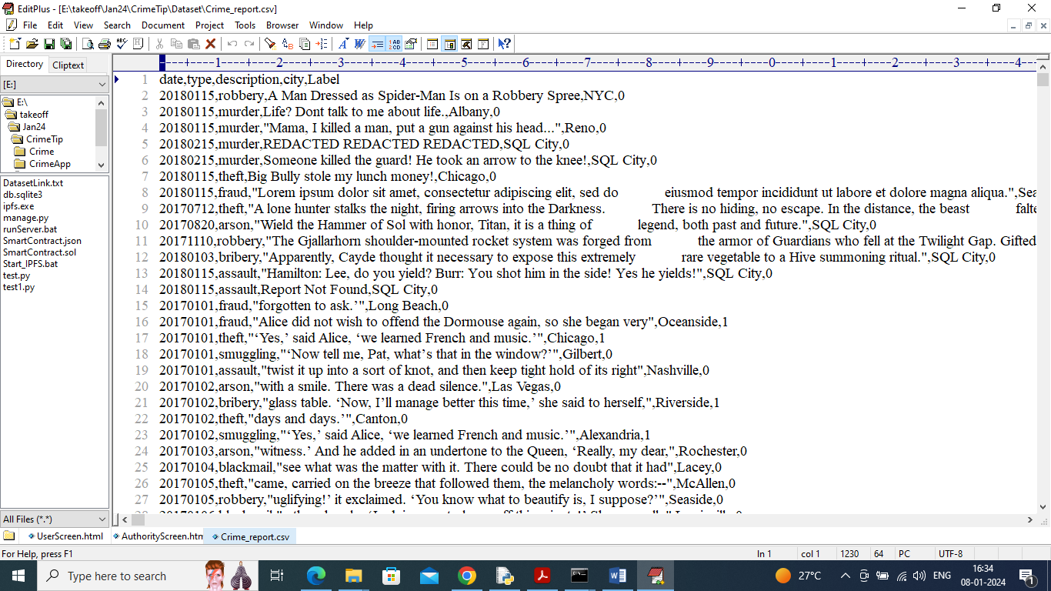

In above dataset screen first row represents dataset column names and remaining rows represents dataset values and in last column we have class label as 0 and 1 where 0 means ‘Crime TIP Description’ is true and 1 means False.

To run project first double click on ‘runIPFS.bat’ file to start IPFS server and get below page

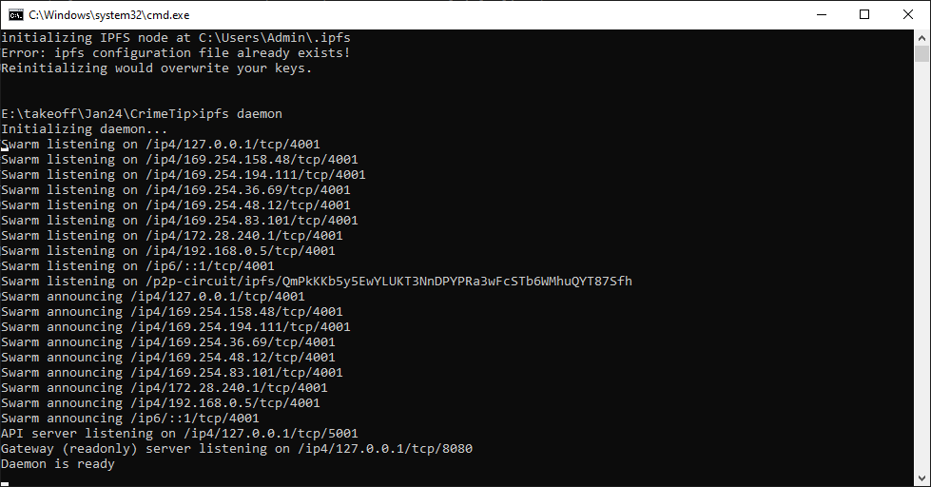

In above screen IPFS server started and now double click on ‘runServer.bat’ file to start python web server and will get below page

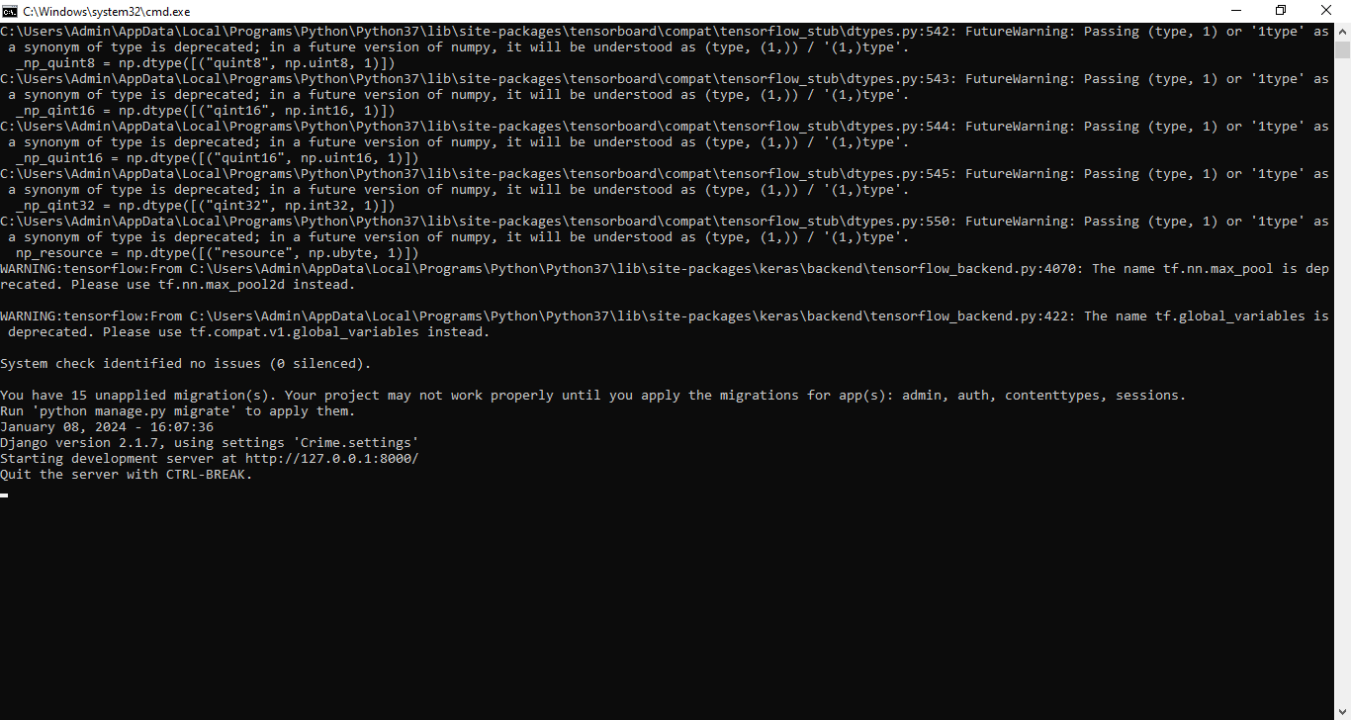

In above screen python web server started and now open browser and enter URL as <http://127.0.0.1:8000/index.html> and then press enter key to get below page

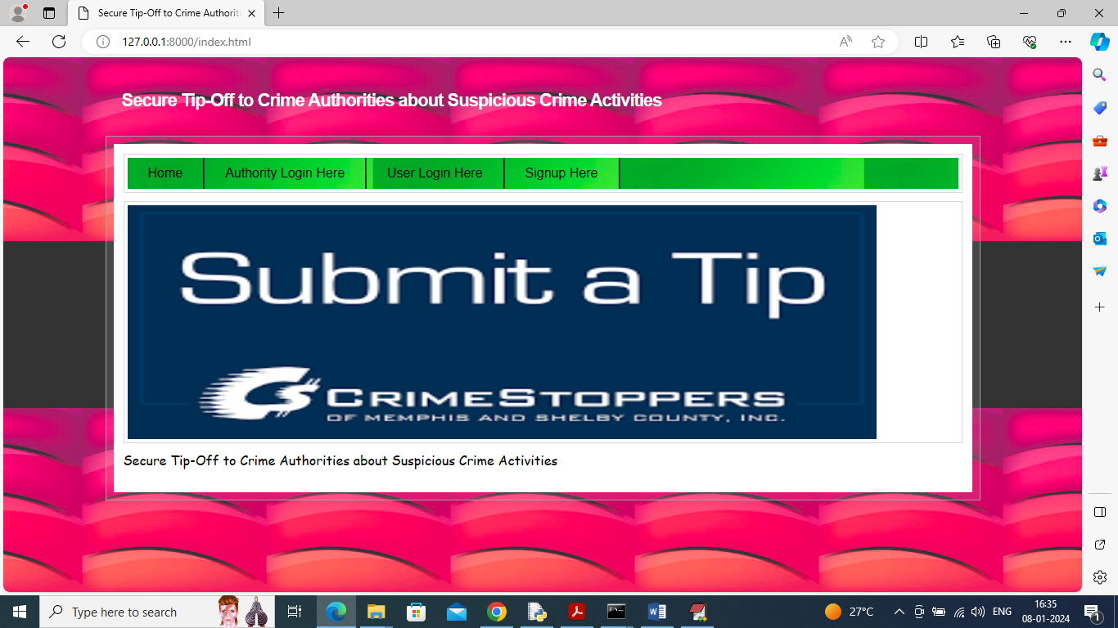

In above screen click on ‘Signup Here’ link to get below page

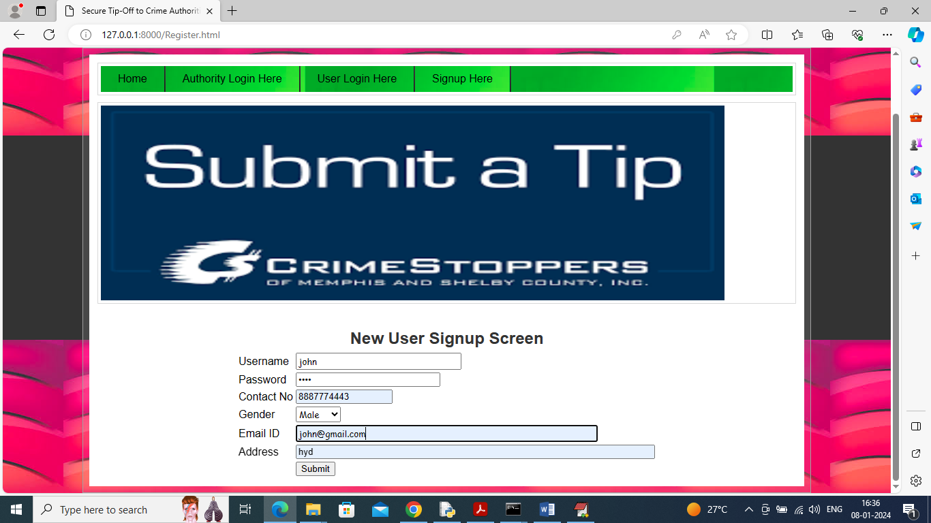

In above screen user is entering sign up details and then press button to get below page

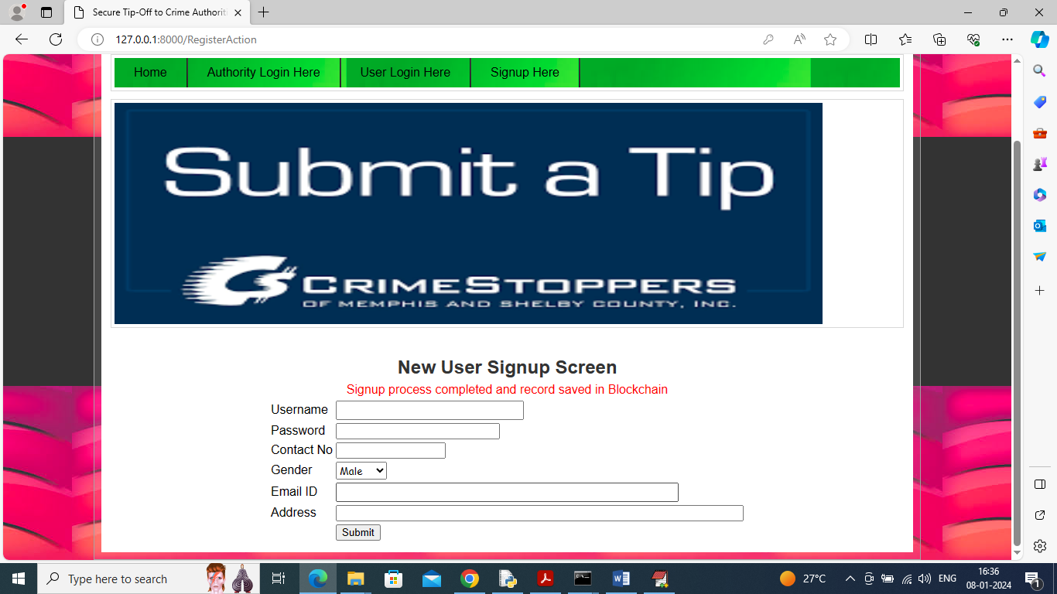

In above screen in red colour text can see sign up data saved in Blockchain and now click on ‘User Login Here’ link to get below page

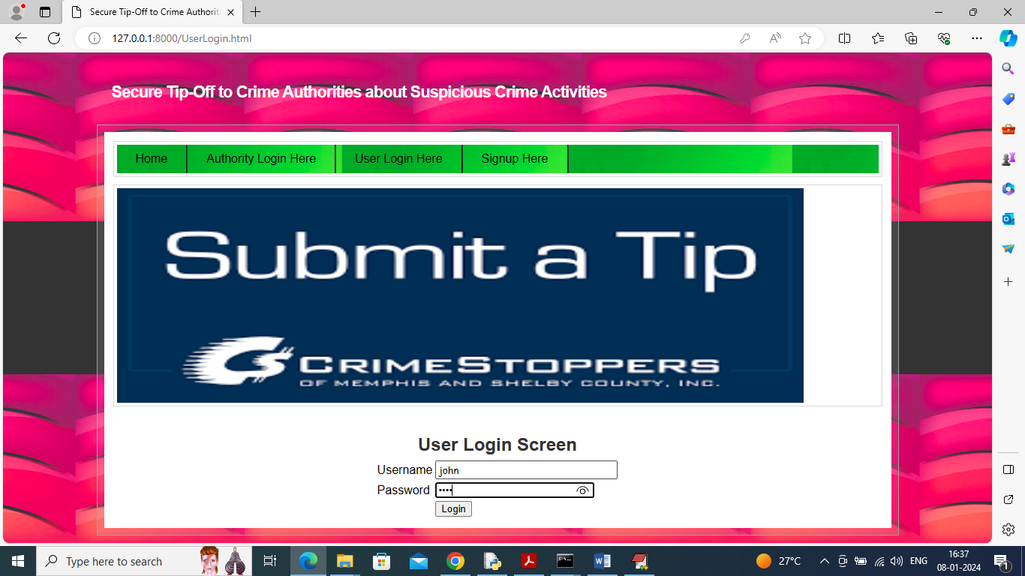

In above screen user is login and after login will get below page

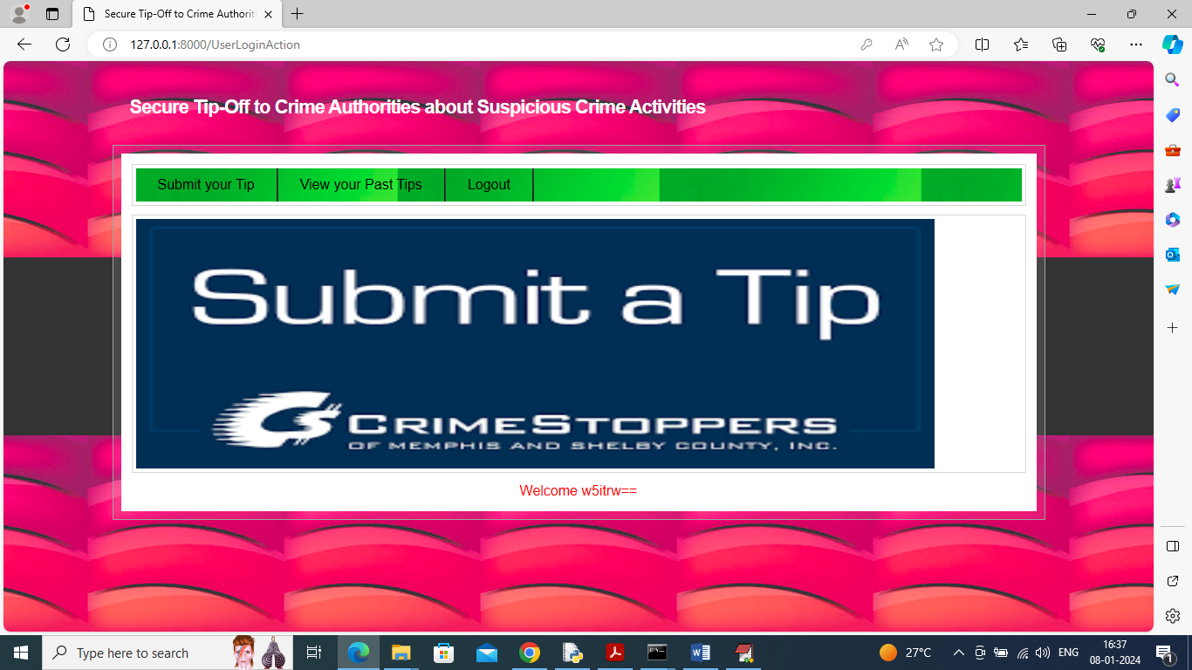

In above screen user can click on ‘Submit Your Tip’ link to get below page

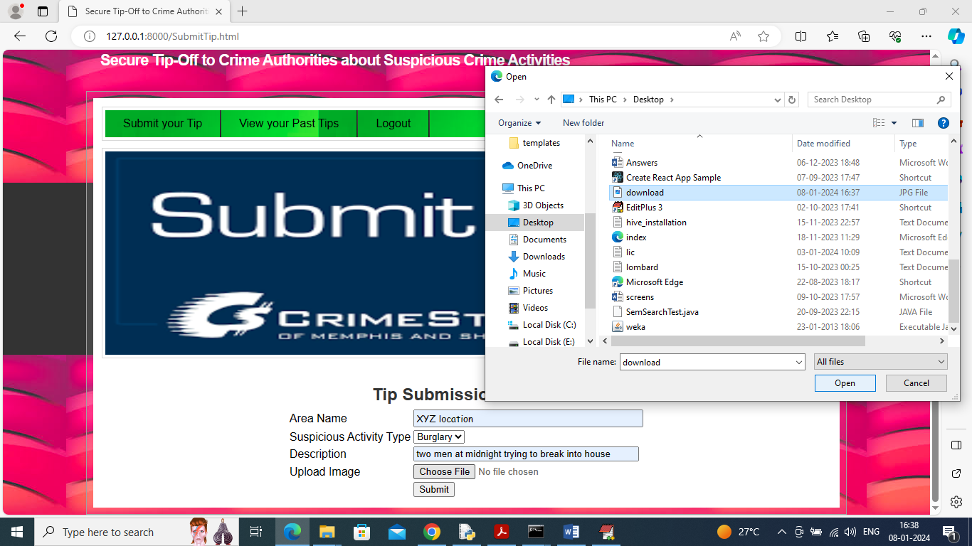

In above screen user will enter address and other details of suspicious activity and can upload image also and then press ‘Open’ and ‘Submit’ button to saved details in Blockchain and then will get below details

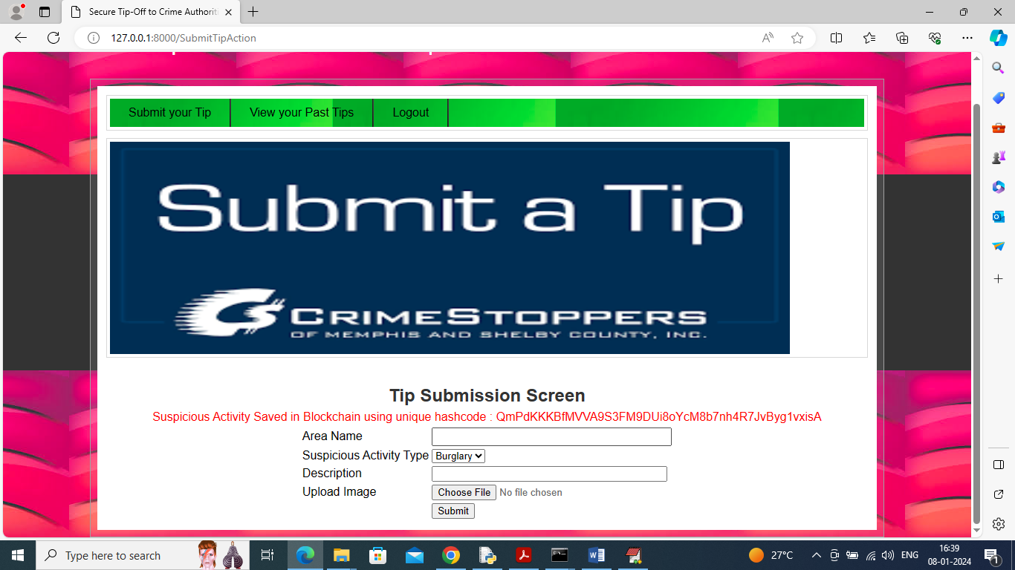

In above screen in red colour text can see details saved in Blockchain and can see stored address in hash code format and now user can click on ‘View Your Past Tips’ link to get below page

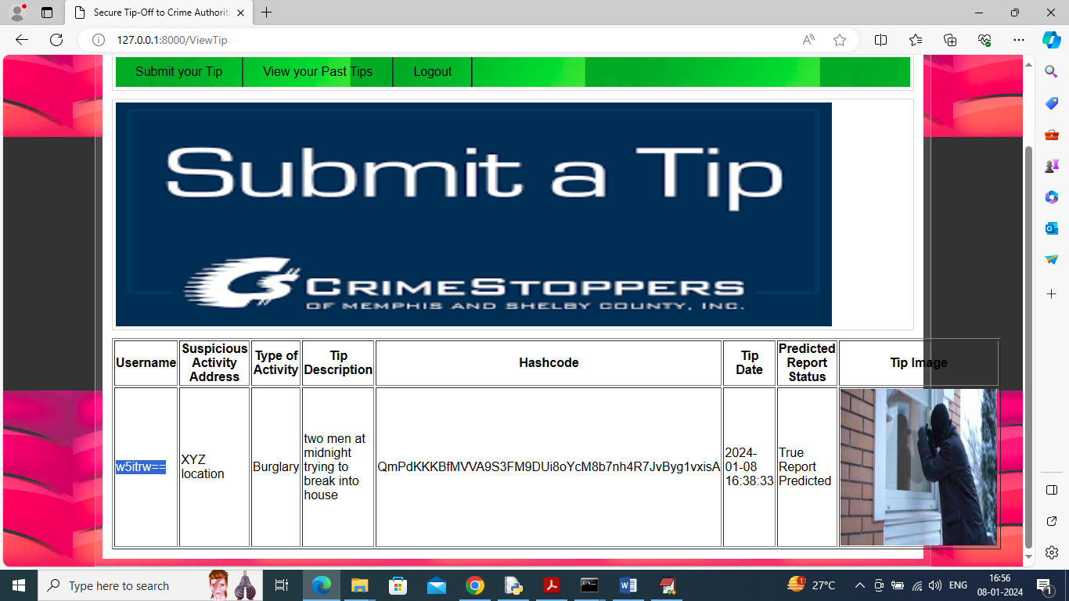

In above screen user can view all his submitted TIPS with images and in first column as username we have anonymised using AES algorithm to provide security to user details and in ‘Predicted Report Status’ can see CNN predicted as ‘True’ and now logout and login as Authority

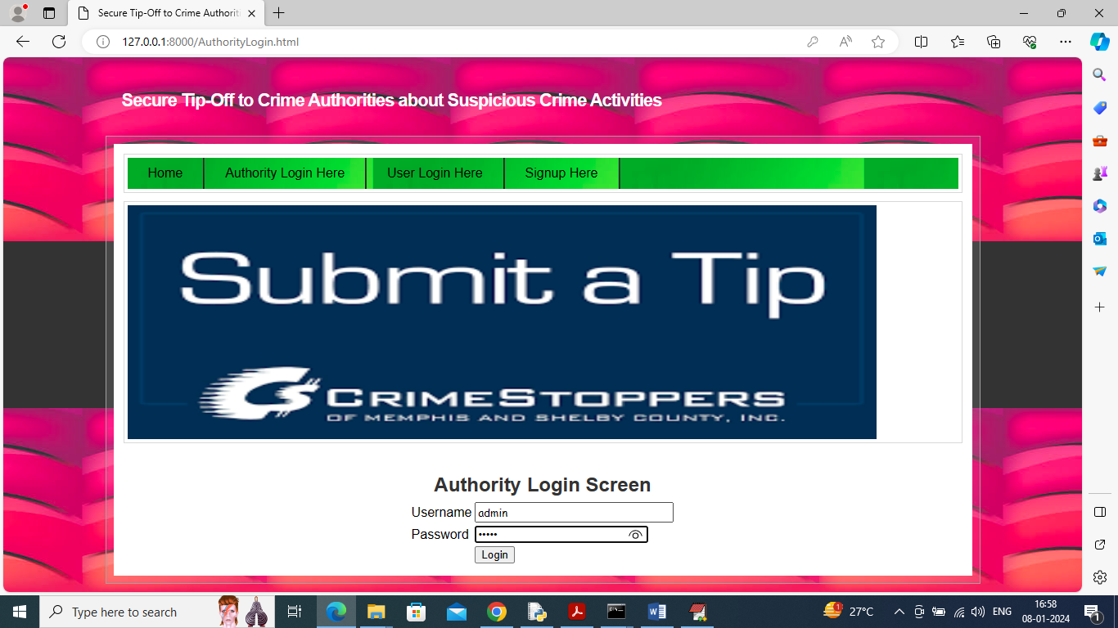

In above screen authority is login and after login will get below page

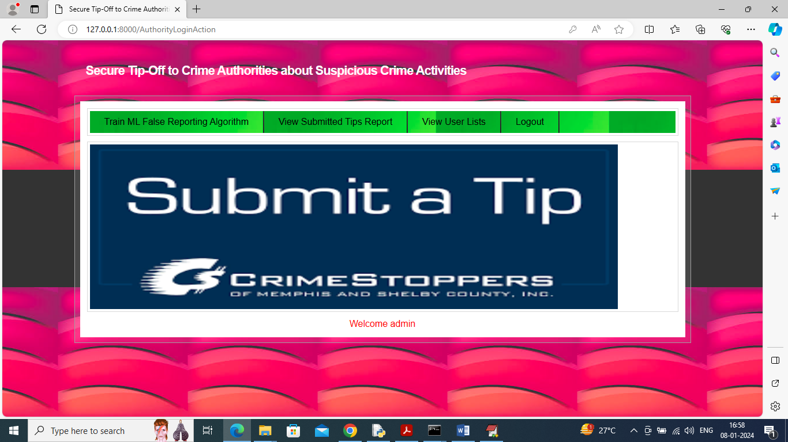

In above screen authority can click on ‘Train ML False Reporting Algorithm’ link to train algorithm on dataset and then will get prediction accuracy

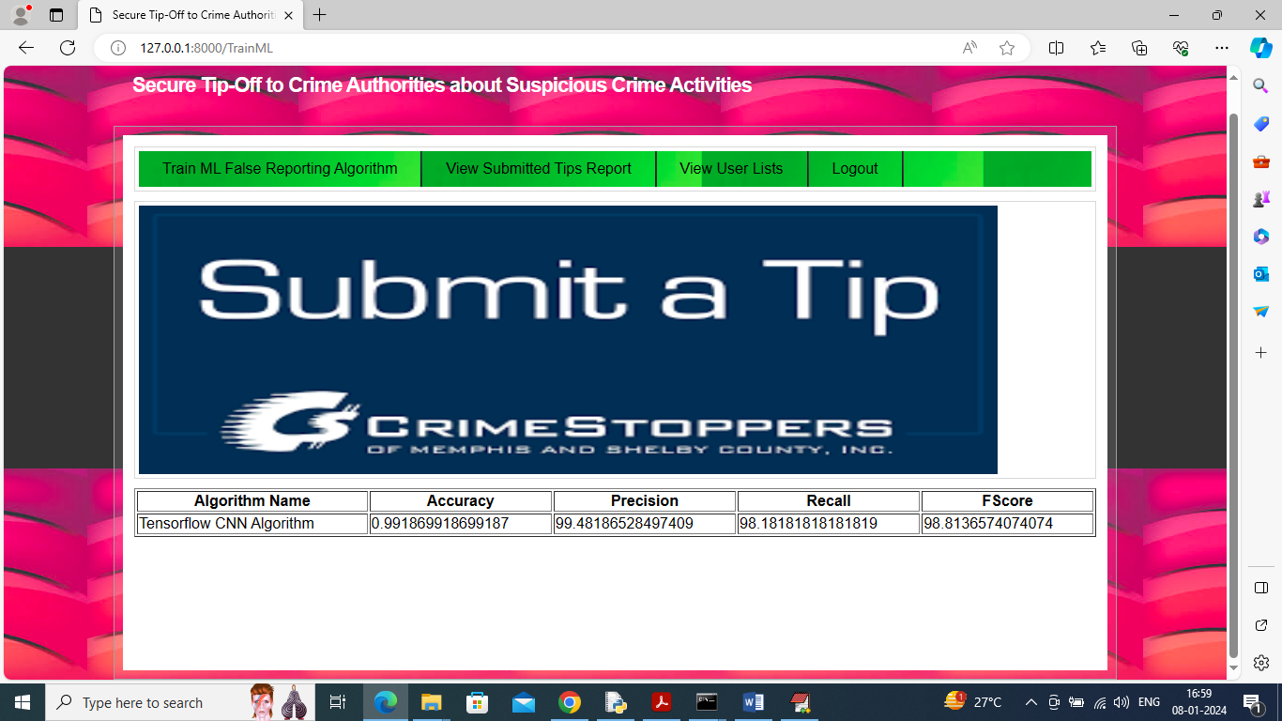

In above screen CNN algorithm got trained on training data and then got 99% accuracy on unseen test data and can see other metrics like precision, recall etc. now click on ‘View Submitted Tips’ link to get tips from all users

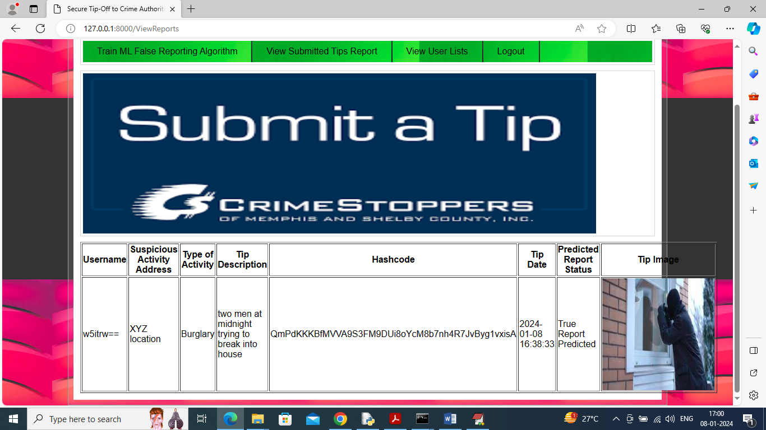

In above screen authority can see all tip details from all users in tabular format with ML predicted report status and username in anonymised format and now click on ‘View Users List’ link to get all registered user details like below page

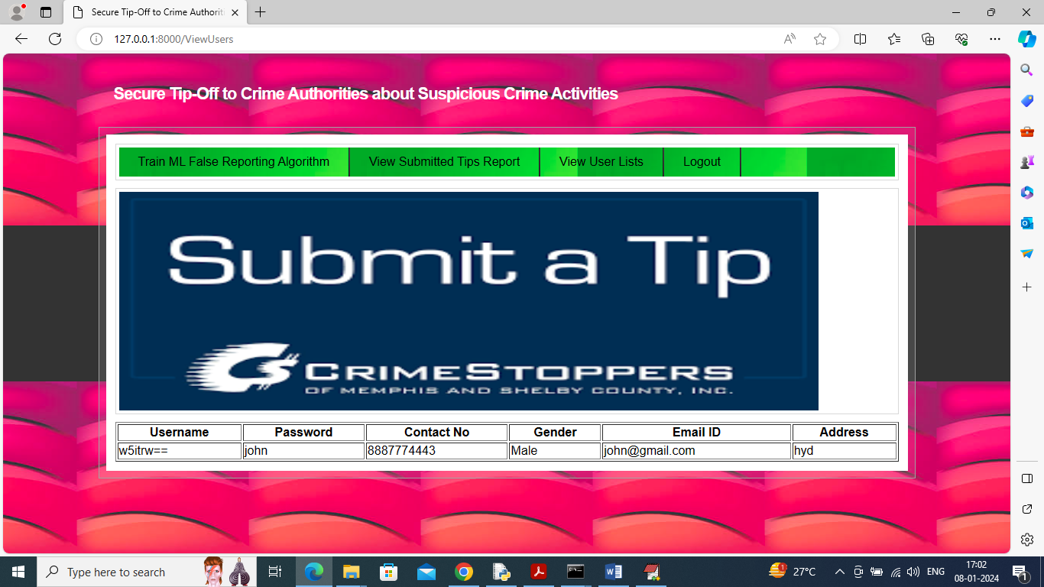

In above screen authority can see all registered user details.

Note: similarly by following above screens you can give N number of TIPS to authorties.